SubSystem title

ERD for UX process

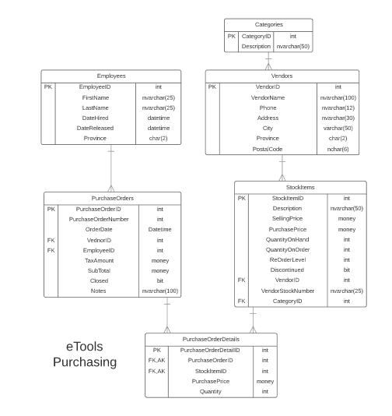

Possible UX Interface
Controls |  | Events
VendorDDL |  | None / ODS
BBL Class(es) and Method (s)
VendorController | List<SelectionList> List_VendorNames()  Retrieve a list of Vendor names and vendor id for DLL
SQL Table(s): (C,R,U,D) |  | Entities/DTOs/POCOs
Vendors (R) |  | SelectionList (P)

Event and Wiring Summations

Controls |  | Events
AddItemButton |  | OnClick  - Validate Qty  - Send to BLL for adding Item to Purchase Order  - Refresh the Purchase Order
BBL Class(es) and Method (s)
PurchaseOrderItemController | Add_ItemToOrder(string username, int sid, int qty, int purchaseorderid)  Add items to Purchase order with SID, Description, QoH, QoO, RoL, QtO & Price  Create the Purchase order if one does not exist  Update subtotals, total, gst(?)
SQL Table(s): (C,R,U,D) |  | Entities/DTOs/POCOs
PurchaseOrderItems (C) |  | PurchaseOrderDetailsList (E)

Controls | Events
RemoveItemButton | OnClick  - Validate item still exists in purchase order  - send to BLL for removing track from Purchase Order  - Refresh the Purchase Order
BBL Class(es) and Method (s)
PurchaseOrderDetailsController | Remove_ItemFromOrder(string username, int sid, int qty, int purchaseorderid)  Update subtotals, total, gst(?)
SQL Table(s): (C,R,U,D) | Entities/DTOs/POCOs
PurchaseOrderDetails (D) | PurchaseOrderDetailsList (E)

Controls |  | Events
SelectVendorButton |  | OnClick
BBL Class(es) and Method (s)
PurchaseOrderController | List_PurchaseOrderDetailsForPurchaseOrder ( string username, int vendorid, int purchaseordeid)  Retrieve the purchase order ( if exists) and display, otherwise, create an empty purchaseorder
SQL Table(s): (C,R,U,D) |  | Entities/DTOs/POCOs
PurchaseOrders (R), PurchaseOrderDetails(R), Vendors (R) |  | Vendors (P)

Controls |  | Events
PlaceOrderButton |  | OnClick  Validate order is not empty  Validate order still exists  Update QoO  Set PO#  Set PODate
BBL Class(es) and Method (s)
PurchaseOrderController | Create_PurchaseOrder(string username, int vendorid, int purchaseordeid)  Set the PO# and OrderDate  Uneditable at this point
SQL Table(s): (C,R,U,D) |  | Entities/DTOs/POCOs
PurchaseOrder (C), PurchaseOrderDetails(C) |  | PurchaseOrder(P)

Controls |  | Events
UpdateOrderButton |  | OnClick  Validate order is not empty  Validate order still exists
BBL Class(es) and Method (s)
PurchaseOrderController | Update_PurchaseOrder(string username, int vendorid, int purchaseordeid)  Update QtO
SQL Table(s): (C,R,U,D) |  | Entities/DTOs/POCOs
PurchaseOrder (C), PurchaseOrderDetails(C) |  | PurchaseOrder(P)

Controls | Events
ClearOrderButton | OnClick  Reset the Page
BBL Class(es) and Method (s)
 | Page resets to empty
SQL Table(s): (C,R,U,D) | Entities/DTOs/POCOs

Comments
You have not demonstrated to me you have a complete understanding of what is really happening in this subsystem. You need to review the specifications and create a much better detailed design plan. You need to have a better screenshot not just the mockup image.

This was not well done.

